Control-M initial Installation

Prerequisites:

Creating logical volume (5GB)

lvcreate -v -L 5G -n ctmlv rootvg

Scanning for logical volumes

lvscan

Create ext4 file system with 5GB

mkfs.ext4 -v /dev/rootvg/ctmlv

Create directory for mounting

mkdir -pv /opt/ctm

Mount the logical volume

mount -v /dev/rootvg/ctmlv /opt/ctm

Display disk usage and file system type

df -hT | grep ctm

Change ownership of the directory

chown -v svczena:zenagrp /opt/ctm

Login as svczena

Su – svczena

Copy the Installation tar archives in /opt/ctm. Through WinSCP

DRKAI.9.0.19.200_AIX – This provides Control-M agent install binaries

Extract zip file

Tar -xvf <file_name>.z

Installation:

Files and Folders are extracted under /opt/ctm. Check all files and folders shows up.

To Install the Control-M Agent run “./setup.sh” as following. Follow the screenshot to enter the command/options on being prompted for User Input.

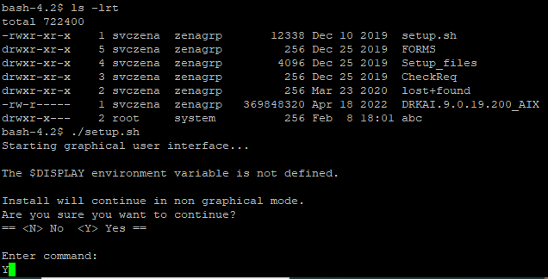

On License Agreement, first press ‘S’ and then ‘Y’.

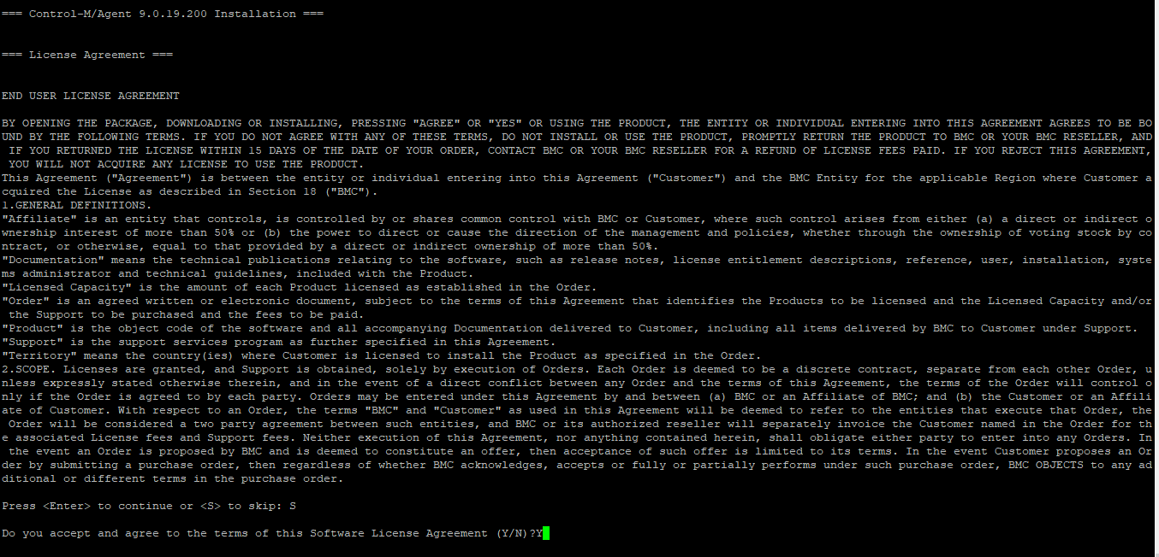

Press ‘1’ to update the Primary Control-M/Server host.

Press ‘2’ to update the Authorized Control-M/Server hosts.

**DEV**

**Primary:** dwauswapp01.adhcscdev.net

**Authorized:** dwauswapp01.adhcscdev.net|dwauswapp02.adhcscdev.net

**TEST**

**Primary:** twauswapp02.adhcsctst.net

**Authorized:** twauswapp02.adhcsctst.net|twauswapp03.adhcsctst.net

**PROD**

**Primary:** pwauswapp02.adhcscint.net

**Authorized:** pwauswapp02.adhcscint.net|pwauswapp03.adhcscint.net

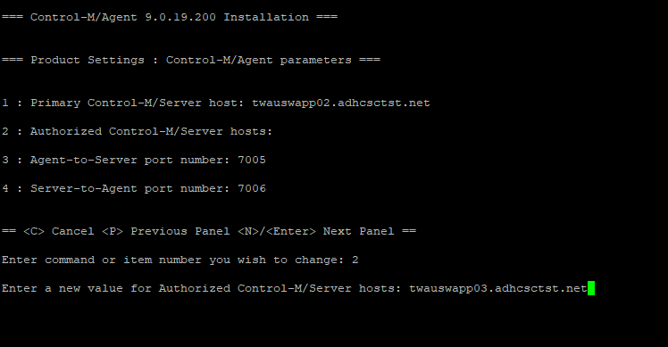

Once all options are filled in, press ‘Enter’ to continue the installation.

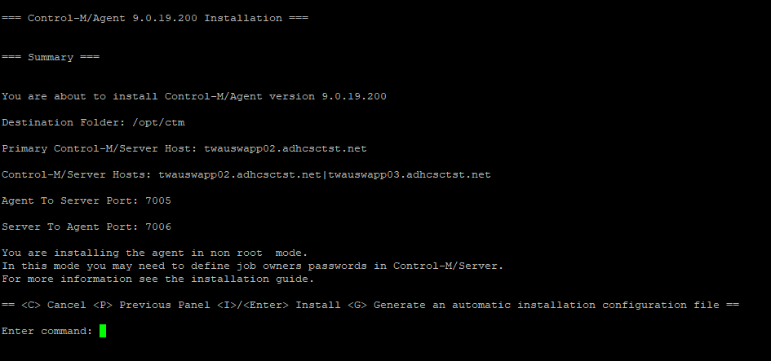

Once Installation completes successfully, run the command ‘ps -ef | grep ctm” to verify Control-M process is running

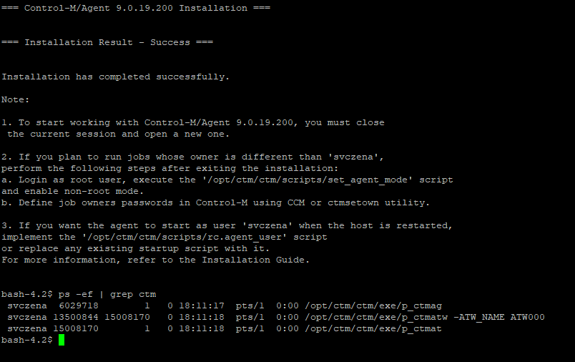

Restart CTM once after installation.

To restart ctm run ./stop-ag.sh and ./start-ag.sh scripts under /ctm/ctm/scripts/ directory.

CTM agent is installed by ‘svczena’ user. So as ‘svczena’ user, run “/opt/ctm/ctm/scripts/ag_diag_comm” to verify Control-M/Agent Comm